
Hardware, Microcontrollers and Sensors

Mohamed Irshad Tharik
CB012791
Contents
Introduction 4
Proposed Solution & System Requirements 4
Hardware Components and Selection 5
Architecture and System Design 6
Software Design & System Operation 7
Features and Embedded System Interfaces 9
Safety system and operating modes 10
Testing and Results 11
Problem face and their solution 14
Conclusion 15
Reference list 15

Introduction
Industries often require an effective way of controlling traffic entering through the loading zone. Traditional gates which are controlled by people often create problems with regard to efficiency and safety. An automated gate system can carry out vehicle monitoring and control operations automatically.
The project describes the implementation of a prototype of a Secure Industrial Loading Gate based on an ESP32 microcontroller. The system makes use of several sensors and output devices to create an automated and safe gate mechanism. The operation begins with a PIR sensor which detects motion and begins the vehicle entry operation. An ultrasonic sensor continues to monitor the distance between a vehicle and a loading gate after the gate opened. The gate is controlled by using a servo motor, and a potentiometer controls the time for which the gate is kept open. Along with the components, an OLED display providing information, a buzzer for warnings and a reset button for emergencies are integrated into the system with the help of an ESP32 program.
This report covers details about system design, operating logic, hardware and software implementation, testing process, safety features, limitations and future improvements of the prototype.

Proposed Solution & System Requirements
The Secure Industrial Loading Gate System was developed to enable automatic vehicle entry while acknowledging the action of the gate. The primary requirement is that the system should recognize vehicles arriving so that the gate opens without the need for continuous manual supervision. After the opening of the gate, the system needs to verify if the vehicle is still within the gate area. The opening of the gate should only be terminated once the vehicle has left the location.
To successfully comply with the abovementioned requirements, the ESP32 microcontroller was chosen as the main control tool for the prototype. The detection of movement of an arriving vehicle is accomplished with the help of a PIR sensor. Once the gate is opened, an ultrasonic sensor allows measuring the distance to the vehicles in front of the gate. The gate remains open while the vehicle is present within the defined area and does not start closing until the vehicle is out.
A potentiometer can be used to modify how long the open state of the gate is to last so that it can be adjusted from user’s perspective conforming to applications conditions. The system has a function related to safety during closing of the gate. The gate operation will be stopped and a buzzer will sound if something comes in the way of the gate. An OLED indicator shows various information about the system, and UART communication serves for the choice of the operation mode
The requirements for the Secure Industrial Loading Gate were prioritized very efficiently using the Moscow technique. The prototype’s requirements were classified into four categories: Must Have, Should Have, Could Have and Won’t Have.

Hardware Components and Selection
The Secure Industrial Loading Gate prototype has many hardware components that are wired to the ESP32 microcontroller. Every component has its own role in the system, which involves detecting vehicles, measuring distances, opening gates, adjusting, indicating status and controlling safety.
The ESP32 serves the purpose of the main controller thanks to its capability to perform sensor processing and control various devices within the same embedded system. According to the information received from the PIR sensor, ultrasonic sensor, potentiometer and reset button, ESP32 is responsible for controlling the servo motor, buzzer and OLED display.
The PIR sensor is responsible for detecting the first movement around the gate. If the movement is detected for a set amount of time, then the ESP32 starts the opening of the gate. Thus, the PIR signal should be maintained for 1.5 seconds for the vehicle to be considered as the moving one.

The ultrasonic sensor HC-SR04 is implemented to measure the distance in front of the barrier. The sensor’s primary purpose is to assess if there is any vehicle still present after the gates opening. The prototype currently runs on two distance thresholds, namely 40 cm for vehicle presence and 20 cm for the closing safety feature.
The physical gate barrier is emulated by means of a servo motor, which rotates between 0 degrees designated for the closed barrier position and 90 degrees for the open position. A potentiometer forms an analog input that makes it possible to set the delay for holding the gate open to the needed duration of about 2-8 seconds.
The system state is shown by means of an OLED display, while the buzzer informs the user about the system being turned on. Lastly, there is a push button that makes it easy for the operator to reset the system after an obstruction is removed.
Component | Connection | Main Purpose
OLED SCL/SDL | GPIO 22/21 | Status Display
HC – HR04 Trig | GPIO 05 | Ultrasonic Triger
HC – HR04 Echo | GPIO 18 | Echo Input Distance
Servo Motor | GPIO 19 | Gate movement
Potentiometer | GPIO 34 | Adjustable open close timer
PIR | GPIO 27 | Motion Detection
Buzzer | GPIO 23 | Safety Alert
Reset Button | GPIO 26 | Recovering Safety

Architecture and System Design
The ESP32 serves as the main processing unit for the Secure Industrial Loading Gate. The entire structure of the system can be sorted into three parts, namely input devices, processing unit, and output devices. Input devices generate data related to movement of the vehicle, distance of the vehicle and user input, while ESP32 processes this data and performs appropriate action for opening and closing of the gate.
The activity of the PIR sensor gives the first movement signal necessary for the start of the vehicle cycle. After detection, of movement will occur using the ESP32, which will manage the servo motor so that the gate is opened. When the gate is open already, the ultrasonic sensor will be responsible for detection of the vehicle. If the distance of a vehicle indicates that the vehicle is present within a specific zone, the gate remains opened. Once the vehicle leaves the zone, the system will implement the delay before the starting of closing.
The potentiometer is used to give an analog input that is utilized to manage the hold-open time. The OLED communicates I2C to the ESP32 and displays the current state of the system. The Serial Monitor uses UART communication for additional monitoring and manual commands. Servo refers to the main gate actuator while the buzzer acts as an alarm.
The architecture also consists of a safety path as it continues measuring distance with the ultrasonic sensor during closing. If the barrier continues to detect anything within 20 cm distance, then the ESP32 will stop the gate from moving and switch to Safety Mode and switch on the buzzer. 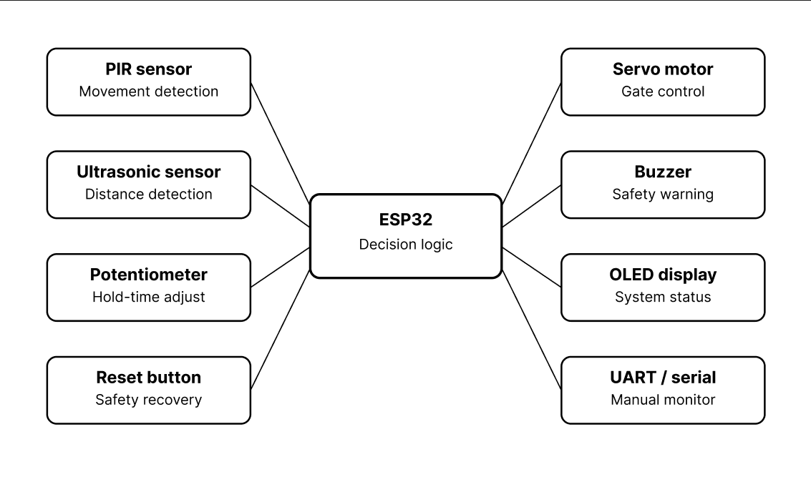
Figure 1-The Secure Industrial Loading Gate prototype's hardware architecture

Software Design & System Operation
The Secure Industrial Loading Gate was programmed in the Arduino IDE for ESP32. The gate operates in various states such as closed, opening, opened, closing, and safety stopped. This method of working opens and closes the gate only when necessary and does not rely on fixed delays.
After the system starts, the gate is closed while the PIR sensor checks its surroundings. The PIR system has to remain clear for a certain amount of time before the system is ready to work to minimize the unnecessary activation of the gate. Once the motion in the vicinity is detected, the ESP32 verifies the detection and proceeds to open the gate. After the initiation of the vehicle cycle, the PIR does not play any role in deciding when to close the gate anymore.
When the door is completely opened, vehicle detection is managed by the ultrasonic sensor; if the distance is lower than vehicle limit distance set up, the system registers the vehicle's presence and keeps the door open, neglecting any current closing timer. Only when the vehicle proceeds, and the distance remains clean enough for a predetermined time, does the system switch to the hold-open timer stage.
The length of this timer is determined by means of a potentiometer, being adjustable from around 2 to 8 seconds, and after the set time is over, the servo starts closing the door. Once the door is closed, the vehicle operation is completed, so the system is waiting for the PIR sensor to stabilize after the action and be ready for the next vehicle.

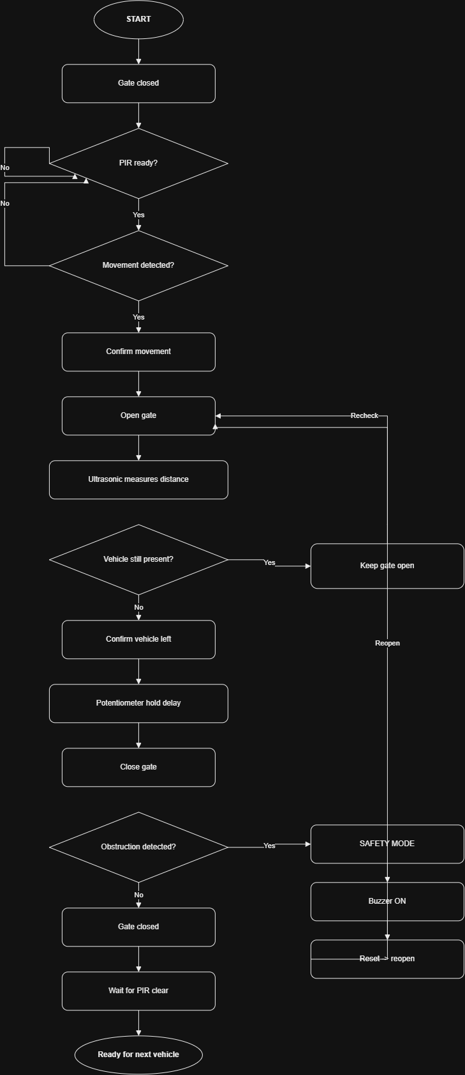
Figure 2-Industrial Loading Gate's operational flowchart

Features and Embedded System Interfaces
Integrated within the Secure Industrial Loading Gate are a number of embedded system interfaces which enable communication of sensors, actuators and user interface devices with the ESP32. These interfaces include digital I/0, ADC, PWM, I2C communication, UART communication and control based on a timer.
Digital Input/Output: Reset button and PIR sensor are two digital inputs that function together. The PIR sensor provides HIGH signals when there is activity and LOW signals when there isn’t any activity. Reset button uses ESP32 internal pull up configuration. The buzzer works as a digital output and is triggered as soon as the system enters the emergency state. These devices are set up in the program.
ADC: The GPIO34 is connected to a potentiometer that produces analog output. The AD is read as analogRead() and is transformed to an adjustable gate holding the door open for the period ranging from around 2 seconds to roughly 8 seconds. Thus it is possible to alter the delay without changing the program.
PWM: The servo motor connected to GPIO19 operates to control the gate. The angle of the servo varies from 0° to 90° corresponding to the closed and open positions of the gate. The servo motion allows the actuator to move to the indicated position to control the physical system.
I2C Communication: The OLED display receives data from the ESP32 board using the I2C protocol. To be precise, GPIO21 operates as SDA (data) and GPIO22 functions as SCL (clock). In addition, the OLED operates with address 0x3C. The OLED display has visual indications about the state of the gate and vehicle detection.
UART Communication: Serial communication occurs at 115200 baud for monitoring the system and sending commands. The commands implemented in the system can enable switching between Auto and Manual modes and opening and closing the gate manually.
Timer-Based Control: The program uses millis() timers to perform different tasks such as confirming the PIR sensor, confirming whether the vehicle has left, controlling the servo movement, and the period of the gate being held in an open-like position which allows to perform multiple tasks without blocking the execution.
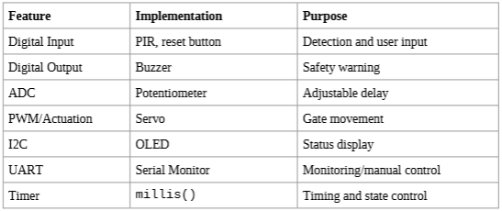

Safety system and operating modes
The security of the Secure Industrial Loading Gate is built on the core component of a safety mechanism, which is responsible for stopping the movement of the barrier whenever there is an obstruction in its path. The developed system includes a specially designed safety mechanism, comprising an ultrasonic sensor, a buzzer, an OLED display, and a reset push button.
The safety check is triggered when the barrier starts shutting down. The ultrasonic sensor detects the distance in front of the barrier. Whenever an object is detected within 20 cm of the barrier the ESP32 invokes the GATE_SAFETY state and activates Safety Mode of the system. The servo motor stopped, holding the barrier at the point of detection. Additionally, the buzzer is activated, and the OLED displays a message to the operator about the need to remove the obstruction and reset the system.
If an obstruction is present in the unsafe zone, the system cannot be reset. Following the removal of the obstacle, when the distance is more than 25 cm, the manufacturer can press the reset button. The buzzer will be silenced, and the system will return to Auto Mode, where the gate will reopen. Therefore, the present vehicle cycle will continue safely.
The program provides three different working modes—Auto Mode, Manual Mode, and Safety Mode, which are well-defined in the software. The Auto Mode operates the gate according to the usual sensor control. The Manual Mode enables an operator to control the gate using UART commands. In this mode, the Serial Monitor accepts the commands “A” for Auto Mode, “M” for Manual Mode, “O” for opening the gate, and “C” for closing it.
Mode | Purpose
Safety mode | Typical automated vehicle detection and gate function
Auto mode | Opening and closing are controlled by the operator via UART
Manual mode | stops the gate from moving when it detects an obstruction.

Testing and Results
Testing of the finished prototype of the Secure Industrial Loading Gate involved checking both the individual parts of the gate as well as the entire automated gate sequence. Testing was performed using the real ESP32 prototype and the Arduino Serial Monitor, OLED display, and the sensors attached to it. Serial monitor proved particularly useful in monitoring such factors as the PIR working status, ultrasound distance, timer duration conditions, operational mode and current state of the gate. The final program provides this data periodically for monitoring and debugging purposes.
Moreover, PIR sensor was tested by performing movement in front of the sensor to ensure that correct movement was able to start the gate opening process. Then the ultrasonic sensor was tested with the help of an object that represented a vehicle in the detection zone as configured. The gate remained open while the object was at the defined distance; when the object was removed, the system started the hold-open timer.
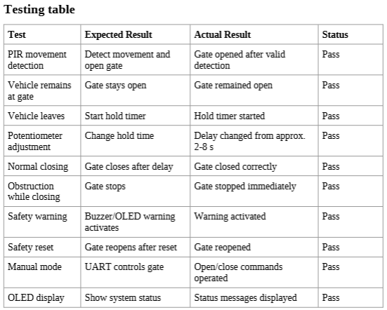
The position of the potentiometer was tested in order to verify that the hold-open time changed from about 2 to 8 seconds. The safety system was tested by putting an obstruction in the path of the closing gate. All operations were performed correctly: the gate was stopped, the buzzer went off, and the system went into Safety Mode. After removing the obstruction and pressing Reset, the gate opened again.

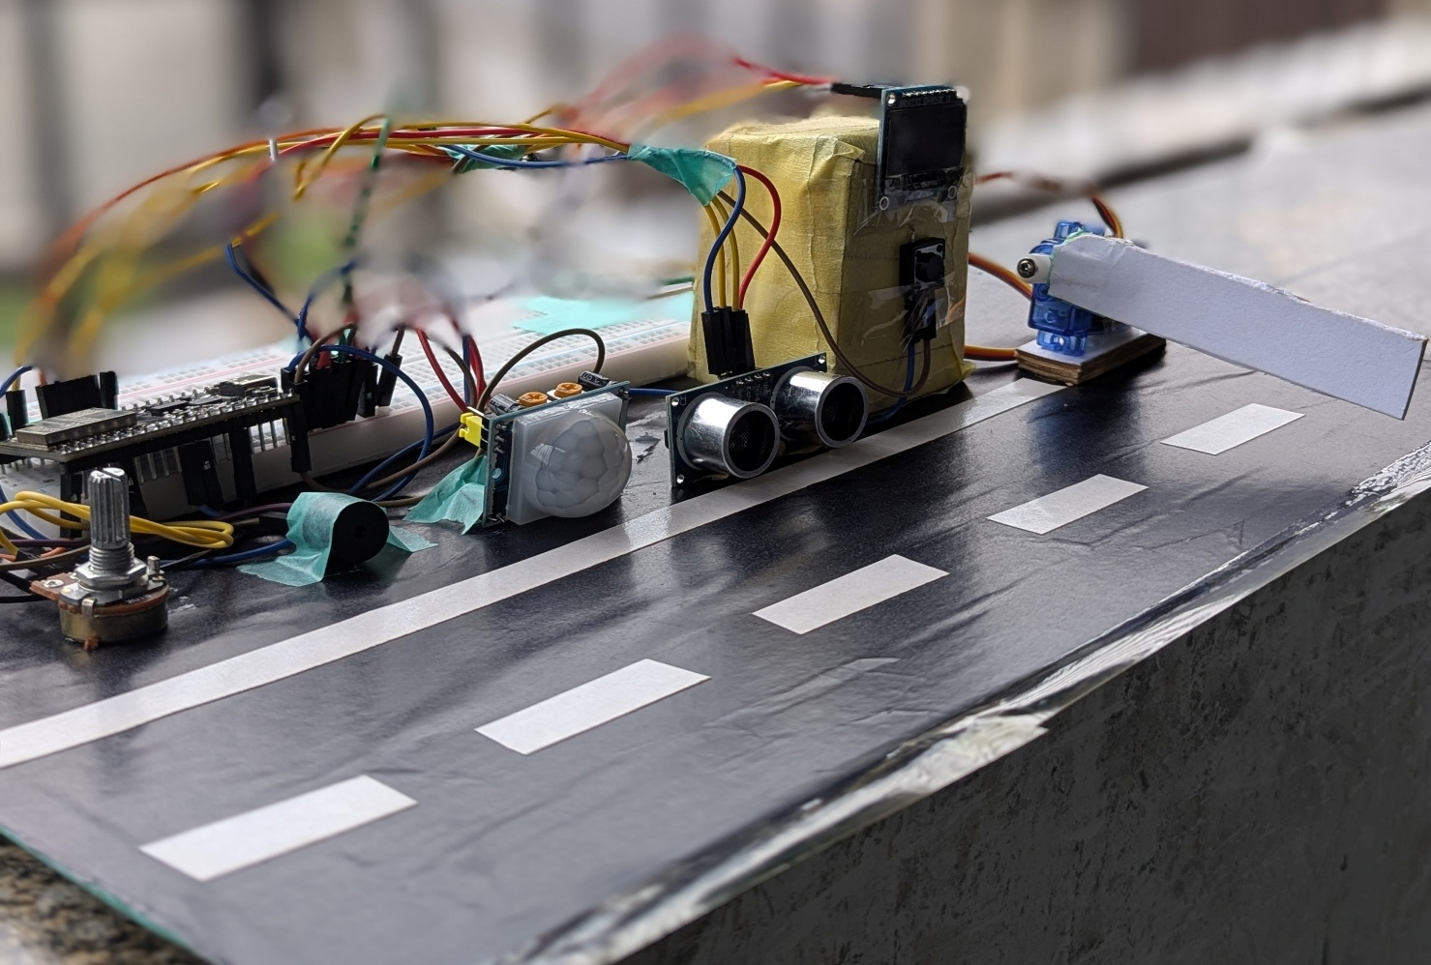

Figure 3- Physical Secure Industrial Loading Gate prototype
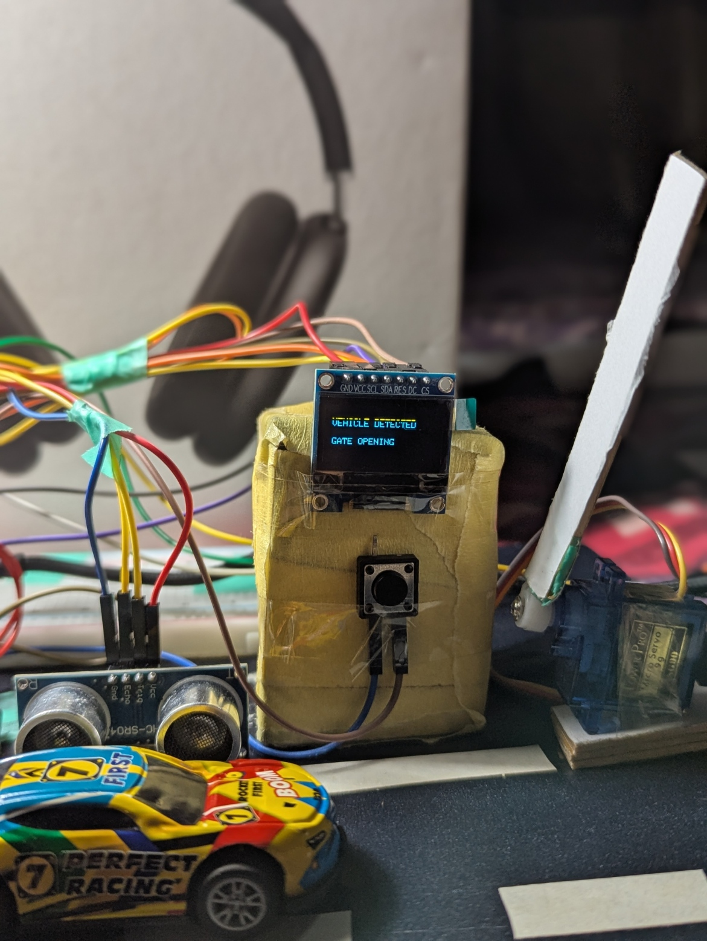
Figure 4- Serial Monitor showing sensor readings and gate status

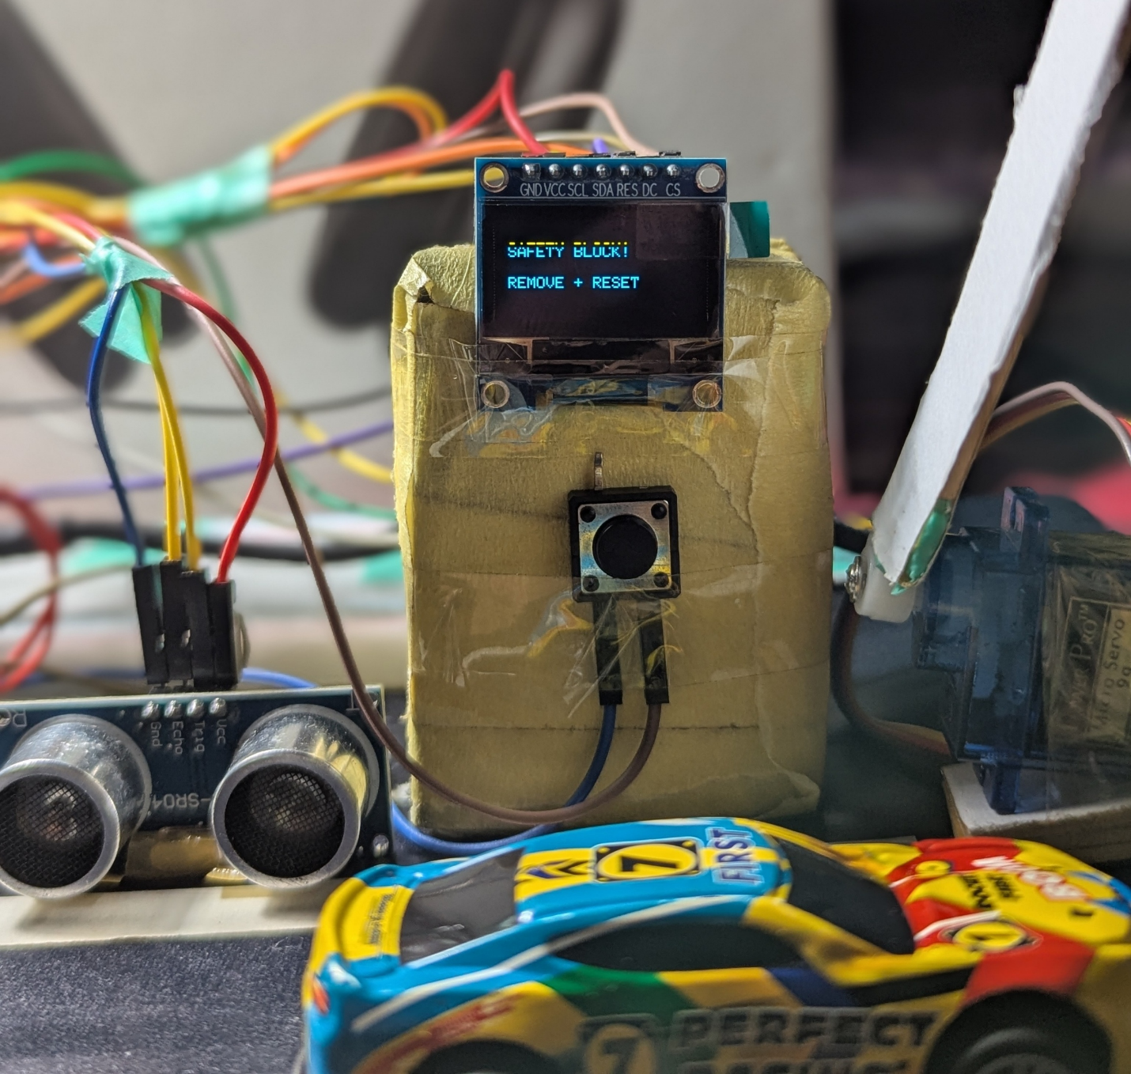
Figure 5- OLED displaying system status or safety warning

In addition, the physical model was examined through the utilization of the OLED screen to validate whether the system offered sufficient visual responses to the operator. During regular operation, the readout showed “VEHICLE DETECTED” and “GATE OPENING” to indicate that a vehicle was present and the barrier was being lifted. For obstruction assessment, the message “SAFETY BLOCK!” and “REMOVE + RESET” was displayed to the operator, indicating that the gate had gone into a safety mode and that the obstruction had to be cleared prior to resetting the system. The evidence of these operating states is shown in Figures 4 and 5.

Problem face and their solution
During the development of the prototype, many practical issues were detected. In the beginning, the PIR sensor brought many detections which could lead to erroneous gate activations, but later improvements made to the PIR sensor's sensitivity resolved the problem, as well as the use of a special software that checks whether movement is a valid vehicle detection or not.
At times the ultrasonic sensor had some false and unstable readings. In order to increase reliability of the measurements the program was programmed so that it checks the reading before deciding that the vehicle leaves the gate zone.
A further difficulty was making certain that the gate did not close in the presence of a vehicle. This was accomplished by constantly keeping track of the ultrasonic sensor while the gate is open and cancelling the closure timer whenever the vehicle is present.
In the first assembly, connecting every component directly in connection with the ESP32 caused messy wiring that made the prototype difficult to inspect and fix. To fix this issue, components were positioned in proper places and their respective wires were organized. It made the general look of the prototype aesthetically cleaner, and hardware connections more identifiable and easier to test as well as to maintain.

Evaluation, Limitations and Future Improvements
The model was able to show the automatic loading gate that used ESP32, sensors, servo motor, and a security feature. There are, however, limitations to the model. The PIR sensor is sensitive to environmental motion, while the ultrasonic readings may sometimes become unstable. In addition, the miniature servo motor is only appropriate for prototyping and not for an actual gate in an industry setting.
There is a possibility of using a better industrial proximity sensor, a stronger gate actuator and RFID access system to identify authorized vehicles in future developments. We could also use data logging or IoT monitoring to capture data regarding vehicle entry and gate performance.

Conclusion
The prototype of the Secure Industrial Loading Gate is able to showcase an automated gate control system based on ESP32. The automated system makes use of ultrasonic and PIR sensors to detect vehicles and makes use of servo motors to move the gate. The system also allows an adjustable hold-open delay to be set with the help of a potentiometer. Safety has been enhanced by stopping the gate if an obstruction is detected along with warning signals given by buzzer and OLED. The prototype demonstrates the use of digital I/O, ADC, PWM, I2C, UART and timer control nicely and fulfills all the actual requirements of safety as well as working of the gate system.

Project Link - https://wokwi.com/projects/474060838689793025

Reference list
Adafruit Learning System. (n.d.). PIR motion sensor. [online] Available at: https://learn.adafruit.com/pir-passive-infrared-proximity-motion-sensor [Accessed 24 Sept. 2026].
Arduino.cc. (2026). [online] Available at: https://docs.arduino.cc/language-reference/?utm_source [Accessed 24 Sept. 2026].
Espressif.com. (2016). GPIO - - — Arduino ESP32 latest documentation. [online] Available at: https://docs.espressif.com/projects/arduino-esp32/en/latest/api/gpio.html?utm_source [Accessed 24 Sept. 2026].
Ultrasonic ranging module HC -SR04. (n.d.). [online] Available at: https://cdn.sparkfun.com/datasheets/Sensors/Proximity/HCSR04.pdf?utm_source [Accessed 24 Sept. 2026].

Appendix Source Code
#include <Wire.h>
#include <Adafruit_GFX.h>
#include <Adafruit_SSD1306.h>
#include <ESP32Servo.h>

// ---------------- PIN CONNECTIONS ----------------
#define PIR_PIN 27
#define TRIG_PIN 5
#define ECHO_PIN 18
#define POT_PIN 34
#define SERVO_PIN 19
#define BUZZER_PIN 23
#define BUTTON_PIN 26

// ---------------- SYSTEM SETTINGS ----------------
#define CLOSED_ANGLE 0
#define OPEN_ANGLE 90
#define DETECT_CM 15 // Vehicle must be 15cm or closer to open
#define VEHICLE_CM 40 // Vehicle presence distance
#define SAFETY_CM 20 // Safety distance while gate is closing
#define RESET_CM 25 // Path must be above 25cm for reset

Servo gateServo;
Adafruit_SSD1306 display(128, 64, &Wire, -1);

// Gate operating states
enum GateState {CLOSED, OPENING, OPEN, CLOSING, SAFETY};
GateState gate = CLOSED;

// System operating modes
enum Mode {AUTO_MODE, MANUAL_MODE, SAFETY_MODE};
Mode mode = AUTO_MODE;

// ---------------- VARIABLES ----------------
float distanceCM = 400;
int servoAngle = CLOSED_ANGLE;
int detectCount = 0;
unsigned long holdTime = 3000;
unsigned long openTimer = 0;
unsigned long servoTimer = 0;
unsigned long sensorTimer = 0;
unsigned long statusTimer = 0;
bool vehicleWasPresent = false;
bool closeTimerStarted = false;

// ---------------- SETUP ----------------
void setup() {
Serial.begin(115200); // Start Serial Monitor

pinMode(PIR_PIN, INPUT);
pinMode(TRIG_PIN, OUTPUT);
pinMode(ECHO_PIN, INPUT);
pinMode(BUZZER_PIN, OUTPUT);
pinMode(BUTTON_PIN, INPUT_PULLUP);

digitalWrite(BUZZER_PIN, LOW);

gateServo.attach(SERVO_PIN); // Connect servo
gateServo.write(CLOSED_ANGLE); // Start with gate closed

Wire.begin(21, 22); // SDA=21, SCL=22
if (!display.begin(SSD1306_SWITCHCAPVCC, 0x3C)) {
Serial.println("OLED NOT FOUND");
}

showOLED("GATE CLOSED", "AUTO MODE");
Serial.println("SYSTEM READY");
}

// ---------------- MAIN LOOP ----------------
void loop() {
readPotentiometer(); // Read adjustable 2-8 second delay
readUltrasonic(); // Read vehicle distance
readSerial(); // Read UART commands

if (mode == AUTO_MODE) automaticMode();
if (mode == SAFETY_MODE) safetyMode();

updateServo(); // Move gate
checkSafety(); // Check obstruction while closing
printStatus(); // Show information in Serial Monitor
}

// ---------------- AUTOMATIC MODE ----------------
void automaticMode() {
bool motion = digitalRead(PIR_PIN);

// CLOSED: PIR detects motion and ultrasonic confirms vehicle within 15cm
if (gate == CLOSED) {
if (motion && distanceCM <= DETECT_CM) {
detectCount++;
} else {
detectCount = 0;
}

// Two correct readings confirm a real vehicle
if (detectCount >= 2) {
detectCount = 0;
vehicleWasPresent = false;
closeTimerStarted = false;

Serial.println("VEHICLE DETECTED");
Serial.println("GATE OPENING");
showOLED("VEHICLE DETECTED", "GATE OPENING");

gate = OPENING;
}
}

// OPEN: keep gate open while vehicle is within 40cm
else if (gate == OPEN) {
if (distanceCM < VEHICLE_CM) {
vehicleWasPresent = true;
closeTimerStarted = false;
showOLED("GATE OPEN", "VEHICLE PRESENT");
}

// Vehicle has moved away
else {
if (vehicleWasPresent && !closeTimerStarted) {
openTimer = millis();
closeTimerStarted = true;

Serial.println("VEHICLE LEFT");
showOLED("VEHICLE LEFT", "WAITING");
}

// Start timer even if vehicle quickly passed through
if (!vehicleWasPresent && !closeTimerStarted) {
openTimer = millis();
closeTimerStarted = true;
}

// Close after potentiometer selected delay
if (closeTimerStarted && millis() - openTimer >= holdTime) {
closeTimerStarted = false;
vehicleWasPresent = false;

Serial.println("GATE CLOSING");
showOLED("ROAD CLEAR", "GATE CLOSING");

gate = CLOSING;
}
}
}
}

// ---------------- ULTRASONIC SENSOR ----------------
void readUltrasonic() {
if (millis() - sensorTimer < 100) return; // Read every 100ms
sensorTimer = millis();

digitalWrite(TRIG_PIN, LOW);
delayMicroseconds(2);
digitalWrite(TRIG_PIN, HIGH);
delayMicroseconds(10);
digitalWrite(TRIG_PIN, LOW);

long duration = pulseIn(ECHO_PIN, HIGH, 30000);

// Use 400cm when there is no valid echo
if (duration == 0) {
distanceCM = 400;
} else {
distanceCM = duration * 0.034 / 2.0;
if (distanceCM < 2) distanceCM = 400;
}
}

// ---------------- POTENTIOMETER ----------------
void readPotentiometer() {
int potValue = analogRead(POT_PIN); // Read ADC value 0-4095
holdTime = map(potValue, 0, 4095, 2000, 8000); // Convert to 2-8 seconds
}

// ---------------- SERVO CONTROL ----------------
void updateServo() {
if (millis() - servoTimer < 10) return; // Control servo speed
servoTimer = millis();

// Slowly open gate from 0 to 90 degrees
if (gate == OPENING) {
if (servoAngle < OPEN_ANGLE) {
servoAngle++;
gateServo.write(servoAngle);
} else {
gate = OPEN;
vehicleWasPresent = false;
closeTimerStarted = false;

Serial.println("GATE OPEN");
showOLED("GATE OPEN", "CHECKING VEHICLE");
}
}

// Slowly close gate from 90 to 0 degrees
else if (gate == CLOSING) {
if (servoAngle > CLOSED_ANGLE) {
servoAngle--;
gateServo.write(servoAngle);
} else {
gate = CLOSED;
Serial.println("GATE CLOSED");
showOLED("GATE CLOSED", "AUTO MODE");
}
}
}

// ---------------- SAFETY CHECK ----------------
void checkSafety() {
// Safety works only while gate is closing
if (gate == CLOSING && distanceCM < SAFETY_CM) {
gate = SAFETY;
mode = SAFETY_MODE;

digitalWrite(BUZZER_PIN, HIGH);

Serial.println("SAFETY BLOCK");
Serial.println("GATE STOPPED");

showOLED("SAFETY BLOCK!", "REMOVE + RESET");
}
}

// ---------------- SAFETY RESET ----------------
void safetyMode() {
// Press button after obstruction is removed
if (digitalRead(BUTTON_PIN) == LOW) {

if (distanceCM > RESET_CM) {
digitalWrite(BUZZER_PIN, LOW);

Serial.println("SAFETY RESET");
Serial.println("GATE REOPENING");

showOLED("SAFETY RESET", "GATE REOPENING");

mode = AUTO_MODE;
gate = OPENING; // Reopen gate after safety stop
vehicleWasPresent = false;
closeTimerStarted = false;

delay(300);
}

else {
Serial.println("REMOVE OBSTRUCTION");
}
}
}

// ---------------- UART / SERIAL CONTROL ----------------
void readSerial() {
if (!Serial.available()) return;

char command = Serial.read();

// A = Automatic mode
if ((command == 'A' || command == 'a') && mode != SAFETY_MODE) {
mode = AUTO_MODE;
Serial.println("AUTO MODE");
}

// M = Manual mode
else if ((command == 'M' || command == 'm') && mode != SAFETY_MODE) {
mode = MANUAL_MODE;
Serial.println("MANUAL MODE");
}

// O = Open gate in manual mode
else if ((command == 'O' || command == 'o') && mode == MANUAL_MODE) {
gate = OPENING;
Serial.println("MANUAL OPEN");
}

// C = Close gate in manual mode
else if ((command == 'C' || command == 'c') && mode == MANUAL_MODE) {
gate = CLOSING;
Serial.println("MANUAL CLOSE");
}
}

// ---------------- OLED DISPLAY ----------------
void showOLED(String line1, String line2) {
display.clearDisplay();
display.setTextColor(SSD1306_WHITE);
display.setTextSize(1);

display.setCursor(5, 15);
display.println(line1);

display.setCursor(5, 35);
display.println(line2);

display.display();
}

// ---------------- SERIAL MONITOR ----------------
void printStatus() {
if (millis() - statusTimer < 1000) return;
statusTimer = millis();

Serial.print("PIR: ");
Serial.print(digitalRead(PIR_PIN) ? "MOTION" : "CLEAR");

Serial.print(" | Distance: ");
if (distanceCM >= 400) {
Serial.print("NO ECHO");
} else {
Serial.print(distanceCM);
Serial.print("cm");
}

Serial.print(" | Hold: ");
Serial.print(holdTime / 1000.0);
Serial.print("s");

Serial.print(" | Mode: ");
if (mode == AUTO_MODE) Serial.print("AUTO");
else if (mode == MANUAL_MODE) Serial.print("MANUAL");
else Serial.print("SAFETY");

Serial.print(" | Gate: ");
if (gate == CLOSED) Serial.println("CLOSED");
else if (gate == OPENING) Serial.println("OPENING");
else if (gate == OPEN) Serial.println("OPEN");
else if (gate == CLOSING) Serial.println("CLOSING");
else Serial.println("SAFETY");
}

Circuit & Wiring Diagram
